# COS20015 Fundamentals of Data Management

## Workshop 5 completed tasks

Alex Vrsecky (104268899)

[Please note: This is a credit level task]

### Workshop 5

**Part 1:**

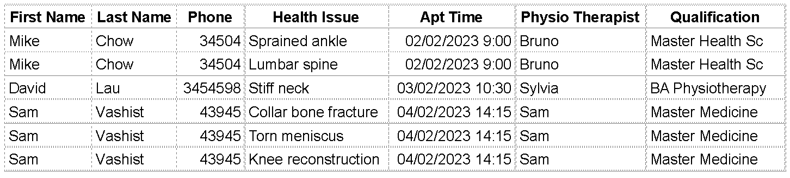

Fix -> Health Issue had multiple values in a single cell.

**Part 2:**

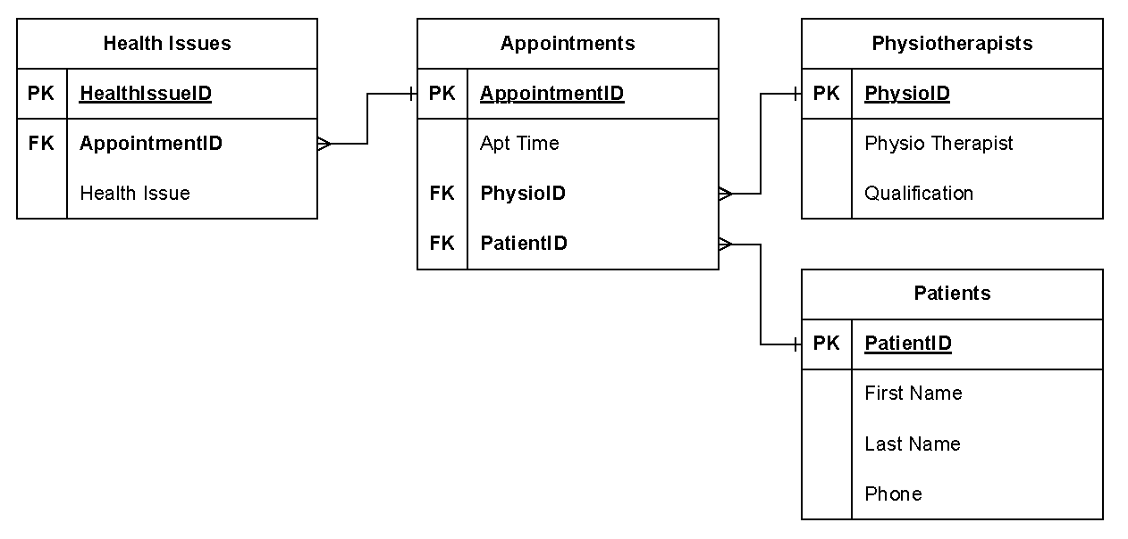

* … 1

* … 1

* … 1

Has no partial dependency. That is, all non-key attributes are fully dependent on a primary key.

**Part 3:**

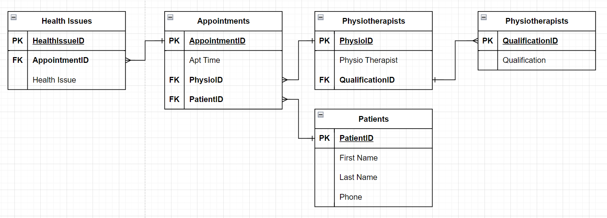

* … 1

* … 1

* … 1

1 … *

Qualification depends on Physio Therapist rather than directly on PhysioID